Phone Down Until Parked: A Social Marketing Approach to Distracted Driving
  - Ali Alattiya, Destiny Seng, Jacqueline Michaels, Johnathan Jagerhofer & Natanya Estacio
  - Northern Alberta Institute of Technology
  - JR Shaw School of Business
  - MARK4201 – Marketing for Social Change (O01.1252)
  - Jennifer Cherneski
  - April 9, 2026

Table of Contents
Executive Summary 4
Phone Down Until Parked: A Social Marketing Approach to Distracted Driving 5
Background, Purpose, and Focus (Step 1) 5
Social Issue & Background 5
Purpose Statement 6
Focus of the Campaign 6
Situation Analysis (Step 2) 7
Strengths (Microenvironment) 7
Weaknesses (Microenvironment) 8
Opportunities (Macroenvironment) 9
Threats (Macroenvironment) 9
Target Audience (Step 3) 10
Segmentation Profile 10
Market Research Findings 12
Behavior Objective and Outcome Goal (Step 4) 12
Behaviour Objective 12
Knowledge Objective 13
Belief Objective 13
Factors Influencing Adoption of the Behavior (Step 5) 14
Perceived Barriers 14
Perceived Benefits 15
Competing Behaviours 15
Influence of Important Others 16
Positioning Statement (Step 6) 16
Positioning Strategy 16
Alignment with Target Audience and Insights 17
Value Exchange and Perceptual Mapping 18
Marketing Mix Strategies (Step 7) 19
Product 19
Price 20
Place 21
Promotion 23
Plan for Monitoring and Evaluation (Step 8) 25
Budget (Step 9) 27
Budget Justification and Benchmarking 27
Budget Allocation (Marketing Mix Alignment) 28
Funding Sources, Cost Savings, and Return on Investment 28
Plan for Implementation and Program Management (Step 10) 29
Conclusion 30
References 31
Appendix A 35

Executive Summary
A quick glance at a phone can change everything. Despite widespread awareness of the risks, distracted driving remains one of the most preventable road safety issues in Canada, yet many drivers continue to engage in it because it feels quick and manageable.
The Phone Down Until Parked campaign targets Edmonton drivers aged 18 to 64, with a focus on tech-dependent individuals. Its goal is to reduce cellphone use while driving by 25% within six months and shift the belief that brief phone use is low risk.
Distracted driving is often automatic, shaped by habit, convenience, and the pressure to stay connected. Many drivers underestimate the danger, especially in situations like stoplights or slow-moving traffic.
Rather than relying on fear, the campaign emphasizes immediate benefits such as reduced stress, better focus, and greater control, while challenging the idea that short distractions are harmless.
The marketing mix supports behaviour change by reducing barriers and increasing appeal. The product promotes keeping phones out of use until parked. The price addresses habit, convenience, and social expectations while reinforcing legal and financial consequences. The place targets key decision-making moments, including intersections and digital spaces. Promotion uses clear messaging such as Phone Down Until Parked.
Supported by a budget of $120,000 to $160,000 and partnerships with government, road safety organizations, insurance providers, and telecommunications companies, the campaign will be evaluated through surveys and observational data.
Overall, this plan provides a focused and practical approach to reducing distracted driving by encouraging realistic, sustainable behaviour change.

Phone Down Until Parked: A Social Marketing Approach to Distracted Driving
Distracted driving remains one of the most persistent and preventable road safety issues in Canada. Although most drivers understand that cellphone use while driving is dangerous, many continue to engage in the behaviour because it feels quick, convenient in everyday situations. This gap between awareness and action highlights the need for a targeted, behaviour-focused social marketing campaign to reduce cellphone-related distractions while driving.

Background, Purpose, and Focus (Step 1)

Social Issue & Background
The social issue addressed in this plan is cellphone-related distracted driving, a significant road safety concern. The focus is on drivers in Edmonton, where urban driving conditions increase opportunities for phone use behind the wheel, particularly in situations perceived as low risk, such as at stoplights or in slow-moving traffic.
One of the key areas for social marketing impacts identified by Lee et al. (2024) includes injury prevention behaviours such as cellphone use while driving (p. 18). In Alberta, over 9,600 distracted driving convictions were recorded in 2025 (Government of Alberta, 2025), while nationally it contributes to 22.5% of fatal collisions and 25.5% of serious injury collisions (Transport Canada, 2024, para. 3). While enforcement strategies of fines and demerits are in place, there is a need for approaches that focusing on behaviour change rather than awareness alone (Government of Alberta, n.d., para. 1).
A gap exists between attitudes and behaviours, as indicated by research from the Canadian Automobile Association showing that most drivers consider cellphone use while driving to be dangerous, yet many still report engaging in the behaviour (D’Arbelles, 2022, para. 2). Observational data in Alberta supports this trend, with handheld device use increasing from 2.6% of drivers in 2013 to 5.3% in 2017, with higher usage observed in urban areas (Alberta Transportation, 2018). Several factors contribute to this issue, including habits, overconfidence in multitasking, and social expectations to remain connected. This gap between high awareness and continued behaviour reinforces the need for a campaign that addresses everyday decision-making, not just knowledge of the risks.
Key stakeholders include the City of Edmonton (Vision Zero), Edmonton Police Service, Alberta Motor Association, Alberta Transportation, Traffic Injury Research Foundation, and Safer Roads Alliance. These government, enforcement, and advocacy organizations already prioritize road safety and are well positioned to support efforts that encourage behaviour change.

Purpose Statement
The purpose of this social marketing plan is to reduce cellphone use while driving among Edmonton drivers. The campaign will promote practical actions of putting phones away before driving or delaying phone use until safely parked.
If effective, this campaign could improve road safety by reducing collisions and shifting social norms so that phone use while driving becomes less acceptable. From an ethical perspective, the campaign will take a supportive approach that promotes voluntary behaviour change, rather than placing blame or judgement.

Focus of the Campaign
The main behaviour this campaign targets is the reduction of cellphone use while driving, including texting, scrolling, and interacting with apps in routine situations. Encouraging drivers to delay phone use until parked presents a clear and achievable behaviour change. Current approaches rely heavily on enforcement and awareness messaging, which have not consistently led to long-term behaviour or social norm change.
This campaign aligns with potential sponsoring organizations such as the Edmonton Police Service, the City of Edmonton’s Vision Zero initiative, and the Alberta Motor Association, all of which would benefit from reduced collisions. There is also strong funding potential, as preventing collisions can reduce health care costs, insurance claims, and other associated impacts.
The greatest opportunity for impact lies in changing everyday driver behaviour. Since cellphone use while driving is both common and normalized, focusing on simple, practical and repeatable behaviour changes allows the campaign to address the issue at its source and supports the situation analysis in the next section.

Situation Analysis (Step 2)
Distracted driving is a major traffic safety issue due to its high levels of risk and normalization. Many drivers still separate serious distracted driving actions of texting, from behaviours perceived as brief and low risk. To better understand this issue, a situation analysis examines internal strengths and weaknesses, as well as external opportunities and threats influencing distracted driving behaviour and the effectiveness of interventions.

Strengths (Microenvironment)
One major strength of a distracted driving campaign is the high level of public awareness surrounding the issue. Unlike some social issues where audiences first need to be convinced a problem exists, distracted driving is already widely recognized as dangerous, with strong public awareness, legal consequences, and institutional support. Transport Canada, the Government of Alberta, the Canadian Automobile Association, and local law enforcement reinforce this messaging, providing strong credibility and a foundation of existing research.
Another strength is the simplicity of the desired behaviour. The campaign does not require drivers to learn new skills but instead encourages them to delay phone use until safely parked, prepare what they need before leaving, and use safer alternatives such as pulling over or going hands-free. This clarity makes the behaviour easier to communicate, adopt, and measure.
A further strength is that the issue has immediate and meaningful consequences that matter to the audience. Drivers are not only risking collisions and injuries, but also fines, demerit points, insurance impacts, and damage to their sense of responsibility. In Alberta, distracted driving carries a $390 fine and three demerit points (Government of Alberta, n.d.), reinforcing the seriousness of the behaviour. As these consequences are both personal and social, there is an opportunity to frame the behaviour in ways that connect with self-interest, safety, and accountability. Together, these strengths allow the campaign to focus on influencing behaviour rather than establishing awareness.

Weaknesses (Microenvironment)
Despite high awareness, one of the biggest weaknesses is the habitual and automatic nature of distracted driving. Drivers may understand the risks but still reach for their phone because they are used to staying constantly connected. Research indicates that problematic smartphone use, habit, and fear of missing out contribute to distractions behind the wheel (Matthias et al., 2023). Thus, weakening the impact of awareness-based messaging alone.
Another weakness is that the behaviour is highly rationalised. Many drivers do not view all types of phone interaction as equally risky. Instead perceiving brief distractions as manageable and low risk, such as glancing at a notification, changing music, or checking directions at a red light. This creates a challenge for campaign messaging because the audience may reject messages that feel exaggerated or inconsistent with their personal experiences. In other words, the problem is not always denial of danger, but selective minimisation (Noble & Douglas, 2025). As a result, messaging strategies must go beyond awareness and address the underlying habits and perceptions driving the behaviour.

Opportunities (Macroenvironment)
There is a strong opportunity to build a campaign around social norms and behaviour design rather than awareness alone. Research shows that descriptive norms, meaning what young drivers think their peers do, are associated with greater mobile phone use while driving (Gauld et al., 2025). A campaign can create value by challenging these false norms and repositioning distraction free driving as the responsible, respected behavioural norm.
Another opportunity exists in demonstrating the simplicity of practical tools and pre-driving routines, since many distractions happen because drivers want convenience. A campaign promoting specific alternatives such as setting navigation before driving, using Do Not Disturb modes, placing phones out of reach, or pulling over safely are easily actionable changing, reducing the gap between intention and behaviour. Alberta RCMP messaging already reinforces this type of practical advice, allowing the social marketing campaign to align with existing safety communication (Royal Canadian Mounted Police, 2026). This creates an opportunity to position the behaviour as both realistic and easy to adopt in everyday driving situations.

Threats (Macroenvironment)
A major threat is the broader culture of constant availability. Mobile phones are designed to capture attention, and social expectations increasingly reward immediate responses. Even when drivers understand the risks, the pressure to check a message or stay updated can override safer choices. Research links distracted driving to fear of missing out and problematic phone use suggests that the issue is reinforced by wider digital habits that exist outside the car as well (Hudecek et al., 2023).
An additional threat exists in message fatigue. Drivers have been exposed to anti-distracted driving messaging for years, which means some audiences may tune out generic warnings. Research on awareness campaigns suggests they can reduce distracted driving in the short term, but effects may weaken over time without reinforcement or broader environmental support (Johns Hopkins Bloomberg School of Public Health, 2024). This highlights the need for approaches beyond awareness alone, instead focusing on sustained behaviour change. Without a separated approach, the campaign risks being ignored or dismissed as repetitive messaging.

Target Audience (Step 3)
To ensure a successful social marketing campaign, it is essential to clearly understand the target audience. A well-defined audience allows messaging and strategies to align with specific motivations, beliefs, habits, and behaviours that influence distracted driving.

Segmentation Profile
The demographic segmentation of this campaign focuses on licensed drivers between the ages of 18 and 64. Within this group, the primary focus is on drivers aged 18 to 34, as this segment demonstrates higher rates of cellphone use while driving. Research indicates that cellphone-related distracted driving is “generally highest among 16- to 24-year-old drivers and lowest among drivers 70 and older” (National Safety Council, n.d.). While distracted driving occurs across all age groups, the underlying motivations for cellphone use vary. Younger drivers are more likely to use their phones for social interaction and immediate communication, whereas older drivers tend to use them for navigation or work-related purposes.
Geographically, the campaign targets drivers within the City of Edmonton, where urban conditions such as frequent stops, intersections, and traffic congestion increase opportunities for cellphone use while driving (City of St. Albert, n.d.). These environments create repeated situations where drivers may feel it is safe to engage with their phones.
The psychological segmentation focuses on drivers’ beliefs that brief phone use is manageable and low risk, particularly in routine driving situations. Attitudes include overconfidence in multitasking, perceived control over driving ability, and social norms that normalize staying connected while driving particularly among adolescents (Stavrinos et al., 2020). In some cases, drivers justify their behaviour by believing that the perceived benefits or the importance of a message or call outweigh the potential risk (Stavrinos et al., 2020).
Behaviourally, the campaign targets drivers who regularly engage in cellphone use while driving, particularly in routine situations such as stoplights or slow-moving traffic. This behaviour is often habitual and driven by convenience, communication needs, and the expectation of constant connectivity.
Using the PRIZM framework, cluster systems within our priority audience can provide a better understanding of their lifestyles, attitudes, and behaviours. Groups such as the Young Digerati represent younger, tech-savvy individuals in urban areas who are responsive to social norms and peer influence (Claritas, 2022). Additionally, the Downtown Verve segment includes young and middle-aged individuals who value excitement and convenience, with technology playing an important role in providing a sense of control in their daily lives. These segments are especially relevant because they reflect the technology dependence, urban lifestyle, and social influences that contribute to distracted driving behaviour within the priority audience.

Market Research Findings
This priority audience was selected because distracted driving behaviours are more common within this group and closely align with the campaign’s objectives. In addition, this group is highly reachable through digital platforms and is more likely to respond to behaviour-focused and social norm-based messaging.
The campaign will be able to tailor messages based on the motivations, beliefs, habits, and values of the target audience. Young drivers who use their phones while driving for social communication and are confident in their ability to multitask, may respond more effectively to messages that emphasize peer influence, social consequences, and real-world risk. In contrast, drivers who rely on their phones for convenience may respond better to strategies that challenge perceived necessity and promote practical alternatives.
Focusing on an urban environment, such as Edmonton, also increases campaign effectiveness, as messaging can be placed in high-risk areas where distracted driving is more likely to occur, such as busy intersections, commuter corridors, and stop-and-go traffic routes. Incorporating realistic driving scenarios into messaging can improve relevance, relatability and increase the likelihood of behaviour change.

Behavior Objective and Outcome Goal (Step 4)

Behaviour Objective
The purpose of this campaign is to reduce cellphone use while driving among drivers aged 18 to 34 in Edmonton by encouraging them to adopt the behaviour of waiting until they have reached their destination before using their phone. The campaign aims to achieve a 25% reduction in self-reported cellphone use while driving over a six-month period. Progress will be tracked monthly through a combination of pre- and post-campaign surveys and available enforcement data to assess changes in behaviour over the six-month campaign period.
Although this behaviour is simple, cellphone use while driving has increased over time, indicating that awareness alone is not enough to change behaviour (National Safety Council, n.d.). As a result, the campaign will focus on addressing habits, social norms, and misconceptions that contribute to distracted driving.

Knowledge Objective
Distracted driving is a major contributor to motor vehicle collisions, with cellphone use identified as one of the most common forms (National Safety Council, n.d.). However, many drivers continue to underestimate the risks or overestimate their ability to safely multitask while driving.
The campaign aims to increase awareness that cellphone-related distracted driving is unsafe and a significant contributor to collisions. Specifically, the goal is to achieve a 25% increase in awareness among the priority audience over the six-month campaign period. Changes in awareness will be measured through pre- and post-campaign surveys assessing recognition of the risks and consequences associated with cellphone use while driving.

Belief Objective
Many drivers believe that brief interactions with their phones, such as checking a message or notification, are harmless. This belief reinforces continued engagement in distracted driving behaviour.
The campaign aims to shift this perception by increasing agreement with the belief that even a few seconds of phone use while driving poses a safety risk. The target is to achieve a 25% increase in agreement with this belief among the priority audience over the six-month campaign period. These changes will be measured through pre- and post-campaign surveys evaluating shifts in attitudes and perceived risk. While belief change may not immediately result in behaviour change, it is expected to influence how drivers perceive “just a second” distractions and support longer-term behaviour change.

Factors Influencing Adoption of the Behavior (Step 5)
Safe driving behaviour is shaped by attitudes, habits, perceived control, social norms, and environmental triggers. A major factor is risk perception. Many drivers understand that distracted driving is dangerous, but still believe their own behaviour is less risky than other people’s. For example, someone may criticize texting while driving but still think checking a notification or changing music is harmless. Phone use is also deeply built into everyday routines, so distracted driving often happens automatically rather than as a deliberate choice. This is made worse by habits linked to constant phone checking, boredom, traffic delays, and fear of missing out (Matias et al., 2021). When drivers believe their friends, family, or peers regularly use phones behind the wheel, safer behaviour can feel less normal or less necessary. This suggests that distracted driving is often driven by automatic decision-making and social reinforcement rather than deliberate risk-taking, which has important implications for behaviour change strategies.

Perceived Barriers
One of the biggest barriers to avoiding phone use while driving is convenience. Many drivers feel pressure to stay connected, whether that means answering messages, checking directions, or changing music, and ignoring the phone can feel inefficient or socially uncomfortable. Another barrier is overconfidence, and some drivers believe they can safely multitask, particularly if they only glance away briefly or use their phone while stopped in traffic. This belief reduces the perceived seriousness of the behaviour and makes safer choices seem unnecessary. There is also a social cost involved (Carter et al., 2014). Delayed responses can make people feel rude, out of the loop, or worried they are missing something important (Gauld et al., 2025). Together, these factors help explain why awareness of the danger alone is often not enough to stop the behaviour.

Perceived Benefits
The clearest benefit of avoiding phone use while driving is improved safety. Focused driving reduces the risk of collisions, injuries, and harm to others on the road (McKay, n.d.). Still, the campaign should not rely on safety alone; it should also stress immediate and personally relevant benefits, such as peace of mind, lower stress, and fewer distractions while driving. Financial and legal benefits are important too, since avoiding distracted driving can help prevent fines, demerit points, insurance increases, and other penalties (Edmonton Police Service, 2026). The behaviour can also be framed positively as a sign of responsibility, maturity, and self-control. Positioning safer driving as something smart and capable drivers do may be more persuasive than simply telling people to follow the rules.

Competing Behaviours
The main competing behaviour is everyday phone use while driving, including texting, checking notifications, changing songs, using apps, and interacting with screens at stoplights or in traffic. These behaviours are difficult to challenge because they offer immediate rewards like convenience, stimulation, and the feeling of staying connected. Broader competing forces include digital habits, boredom, time pressure, and the belief that a quick interaction is harmless. Modern in-car screens and infotainment systems can also divide attention, even when drivers do not think of them as distractions (Canadian Automobile Association, n.d.). In many cases, distracted driving feels productive because people see the car as another place to catch up on tasks, which makes the unsafe behaviour harder to replace. This shows that the behaviour is reinforced not just by convenience, but also by everyday habits and routines, which makes it harder to change without more targeted approaches.

Influence of Important Others
Important others strongly shape whether distracted driving is normalized or discouraged. Friends and peers are especially influential because people are more likely to use their phones while driving if they believe others around them do the same (Trivedi et al., 2017). Parents and family members matter too, since they model driving behaviour over time and shape what feels acceptable behind the wheel. Passengers can also influence behaviour in either direction. In some cases, they increase distraction, but they can also help the driver stay focused by assisting with navigation or reducing unnecessary interruptions. Beyond personal relationships, institutions such as police, governments, schools, and road safety organizations reinforce social norms and consequences. Their role is important because they help position distracted driving as not only illegal, but also irresponsible and avoidable.

Positioning Statement (Step 6)

Positioning Strategy
A benefits-focused and behaviour-focused positioning strategy will be used in this campaign to encourage drivers to reduce cellphone use while driving. In social marketing, positioning is used to influence how a behaviour is viewed so that it becomes more appealing and relevant than the alternative (Lee et al., 2024). Rather than simply emphasizing the dangers of distracted driving, this campaign reframes the safer behaviour as a practical, realistic, and beneficial choice that fits within everyday driving situations.
This campaign aims to position distraction-free driving as a simple, achievable, and empowering behaviour for tech-dependent drivers in Edmonton, particularly younger and highly connected individuals. Compared to the competing behaviour of quickly checking a phone, which is often perceived as convenient and low risk, staying focused on the road is framed as the more valuable choice. This is because it provides immediate benefits such as increased awareness, improved reaction time, reduced stress, and greater confidence while driving. This aligns with the group’s findings that many drivers are aware of the risks but continue to justify brief phone use in situations such as stoplights or slow-moving traffic.

Alignment with Target Audience and Insights
The positioning is grounded in key audience insights, including the normalization of phone use, habitual behaviour patterns, and the belief that short interactions are harmless. As identified in the group’s research, distracted driving is often not a deliberate risk-taking behaviour. Instead, it is an automatic response triggered by notifications, boredom, or social pressure to stay connected. This matches findings from earlier research that distracted driving is mainly driven by habit, perceived control, and social expectations rather than lack of awareness.
According to Lee et al. (2024), effective positioning must reflect the audience’s perceived barriers and benefits, ensuring that the desired behaviour feels more worthwhile than the competing one. In response to these findings, the campaign increases the perceived cost of distracted driving by emphasizing immediate and relatable consequences, while strengthening the perceived benefits of staying focused, such as maintaining control, protecting others, and avoiding legal and financial consequences.
Additionally, external research supports the importance of addressing these misperceptions. Drivers frequently underestimate the risks associated with brief phone use and overestimate their ability to multitask safely (Oviedo-Trespalacios et al., 2017). This helps explain why awareness-based approaches alone are not effective in changing behaviour. By focusing on realistic and relatable situations and promoting small, achievable actions, such as ignoring notifications or preparing phone use before driving, the campaign positions distraction-free driving as an easy and sustainable habit rather than a restriction. This ensures the positioning remains credible and relevant to the priority audience’s everyday experiences.
This positioning strategy directly supports the campaign’s behavioural objective of reducing mobile phone use while driving, as well as its knowledge and belief objectives. By challenging the perception that brief phone use is low risk and reinforcing the benefits of staying focused, the campaign ensures that messaging is consistent and aligned with measurable behaviour change outcomes.

Value Exchange and Perceptual Mapping
The campaign’s positioning reflects the concept of value exchange, where the audience is asked to give up the perceived convenience of checking their phone in exchange for greater safety, control, and peace of mind. This trade-off is intentionally framed as realistic and achievable, rather than restrictive, to increase acceptance among the target audience. By emphasizing that the benefits of staying focused outweigh the short-term convenience of phone use, the campaign increases the likelihood that drivers will adopt and maintain the desired behaviour (Lee et al., 2024).
This positioning is further supported through a perceptual map, which illustrates how the target audience currently views distracted driving compared to the desired behaviour. The horizontal axis represents perceived convenience, while the vertical axis represents perceived risk. Currently, phone use while driving is perceived as high convenience and low risk, particularly in situations such as stoplights or slow-moving traffic. In contrast, distraction-free driving may be perceived as less convenient despite being safer. The goal of the campaign is to shift these perceptions so that distraction-free driving is viewed as both high value and high convenience, while phone use is repositioned as a high-risk behaviour that is not worth the consequences. This shift strengthens the campaign’s value proposition by making the safer behaviour more appealing while reducing the attractiveness of the competing behaviour, reinforcing the overall positioning strategy.

Marketing Mix Strategies (Step 7)
Distracted driving often occurs even when drivers are aware of the risks, as the behaviour is frequently automatic and a part of everyday habits. For this reason, the campaign focuses less on awareness and more on making the safer behaviour feel practical and achievable in reality.

Product
The product strategy explains the behaviour being promoted, the benefits behind it, and the supports that make it easier for the target audience to adopt.
The core product is the set of benefits drivers receive by not using their phone while driving, which include increased safety, reduced risk of collisions, and the protection of passengers and other road users. There are also perceived benefits to the priority audience of avoiding legal or financial consequences such as fines, demerit points, and increased insurance costs. In addition, the behaviour provides psychological benefits to drivers, including feeling more in control of their actions, reduced stress, and improved focus. This is supported by Klauer et al. (2014), who illustrated with empirical evidence that secondary tasks requiring drivers to take their eyes off the road are cognitively demanding and significantly increase the risk of crash or near-crash instances (pp. 54–58).
The actual product is the behaviour itself, which focuses on minimizing or eliminating phone interaction while driving. There are already numerous tools and features available that make this behaviour easier to adopt and successful at changing the behaviour, such as built-in phone settings and apps designed to limit distractions while driving (Delgado et al., 2024). Practical features and actions that can be taken include setting navigation and music before driving, activating Do Not Disturb features, keeping the phone out of reach, and pulling over safely if phone use is necessary.
The augmented product includes additional goods and services that support behaviour adoption and increase appeal. For this campaign these would include quick setup guides for Do Not Disturb features, short instructional videos, social media demonstrations, dashboard reminder cards, and phone lock-screen prompts. These supports reduce effort and help translate intention into consistent behaviour of focusing more on driving.
From a branding perspective, “Phone Down Until Parked” stood out as a clear, memorable way to capture the behaviour. It acts as both a quick reminder for drivers and the core identity of the campaign. However, when considering the ethical implications of the product strategy, it is important that the campaign does not overpromise safety or imply that following the behaviour eliminates all driving risks. The messaging must remain accurate and avoid creating a false sense of security.

Price
The price strategy considers both the monetary and nonmonetary costs associated with adopting the behaviour. For the priority audience of drivers, the monetary cost is minimal, as the behaviour does not require any new technology or purchases. However, some drivers may still perceive optional costs, such as phone mounts, upgraded vehicle features, or paid apps to support behaviour change. In contrast, nonmonetary costs are more significant and include the time and effort required to prepare tasks before driving, psychological discomfort from ignoring notifications, fear of missing out, habit disruption, and a perceived loss of efficiency.
To address these barriers, the campaign focuses on reducing perceived costs while reinforcing the benefits of the desired behaviour. It emphasizes that these actions can be incorporated into existing routines without added expenses, while also highlighting benefits such as improved focus, reduced stress, and a greater sense of control and confidence while driving. Additional incentives may include potential insurance discounts, employer-supported safe driving programs, and increased social motivation, influenced by social norms and the desire to be seen as a responsible driver and model safe behaviour.
At the same time, the campaign works to increase the perceived costs of the competing behaviour. Monetary costs are reinforced through existing penalties, including the $300 fine and 3 demerit points associated with distracted driving in Alberta (Government of Alberta, n.d. b, para. 1). Nonmonetary costs are emphasized through potential emotional consequences, such as guilt, injury, or harm to others, all of which challenge the existing opinion of drivers that the behaviour is low risk or convenient.
From an ethical standpoint, the campaign aims to encourage behaviour change without relying heavily on fear or guilt. While the risks are clearly communicated, the focus stays on giving drivers practical, achievable ways to change their behaviour. It also avoids suggesting solutions that require extra spending, helping ensure the approach is realistic and accessible for a wide range of drivers.

Place
The place strategy focuses on making the behaviour of putting the phone down until parked, and its supporting resources, convenient and accessible by aligning with where and when distracted driving occurs. Three key place strategies presented by Lee et al. (2024), guide this approach: being present at the point of decision-making, being where the priority audience spends their time, and overcoming psychological place barriers (p. 288).
Distracted driving most often occurs in routine environments such as intersections, traffic, and daily commuting routes. As a result, the campaign prioritizes being present at the point of decision-making, where the behaviour of the target audience can be influenced in real time. Research shows that existing sensors and equipment in the vehicle itself has already “shown a reduction in distraction-affected driving behaviours” (Johns Hopkins Bloomberg School of Public Health, 2024, p. 3), reinforcing the value of placing interventions within the driving environment where decisions are made. Additionally, physical locations of intersections, parking lots, gas stations, and high-traffic areas provide opportunities for timely prompts and reminders.
The campaign applies the strategy of being where the priority audience spends their time by using digital environments as key access points. Given the focus of this paper on distracted driving directly linked to cellphone use and the expectation of constant connectivity, these platforms represent the most relevant and effective place to reach the target audience. Platforms such as Instagram and TikTok therefore provide strong channels for campaign exposure and behaviour change reinforcement. Psychological place barriers are also addressed by targeting the belief that brief phone use can be safely managed, particularly in low-risk situations such as stoplights. The campaign makes the risk feel immediate and relevant by linking these moments to real consequences, challenging the perception that “just a quick check” is harmless.
To support campaign accessibility, a combination of direct and partner-based distribution channels is optimal. Zero-level channels include direct access through social media, campaign websites, and in-device features such as Do Not Disturb settings or driving-focused apps, which support behaviour at the exact moment it occurs. One-level channels involve partnerships with the City of Edmonton, aligned with Vision Zero (City of Edmonton, 2020, p. 6), as well as workplaces, post-secondary institutions, insurance providers, and road safety organizations. These partnerships extend the campaign’s reach while reinforcing consistent messaging.
From an ethical perspective, the place strategy needs to consider equitable access and avoid unintentionally excluding certain groups. While digital tools are effective, not all drivers have access to newer technology or data-supported platforms. To address this, the campaign also includes physical and community-based touchpoints to ensure a broader reach.

Promotion
The promotion strategy for this campaign focuses on using persuasive communication, beginning with the message strategy of “Phone Down Until Parked,” which reflects the behavioural direction developed through earlier stages of the marketing mix. This message is simple, clear, and easy to apply, encouraging drivers to delay phone use until they are safely parked. It communicates both the safety benefits and the practicality of the behaviour in everyday driving situations.
The creative strategy focuses on realism and relatability by using everyday driving situations that mirror how distracted driving happens. Multiple creative approaches from Lee et al. (2024) were applied, including keeping the message simple and clear, focusing on audience benefits, and incorporating questions that encourage self-reflection (pp. 307–319).
Three social media advertisements were developed as part of a cohesive campaign set (see Figure A1 in Appendix A), each using a distinct message approach while reinforcing the same behavioural outcome. The ads build on each other, moving from awareness to self-reflection and finally demonstrating the desired behaviour. This approach also reflects the importance of aligning messages with how the audience processes decisions, as “ads that are congruent with an individual’s style of pursuing goals are more effective” (Arnold et al., 2019, p. 3). The first ad challenges the idea that checking your phone is urgent and safe, the second encourages the audience to reflect on their own behaviour, and the third models safer driving with the desired behaviour change. This ad message progression makes them feel more relevant to the audience and easier to apply in real situations. Research shows that “multifaceted campaigns have been credited with short- and longer-term reductions in observed distracted driving” (Arnold et al., 2019, p. 6), supporting multiple message approaches in a campaign.
The messenger strategy focuses on using sources that feel both credible and relatable to the target audience. This includes paramedics, driving instructors, and healthcare professionals, who act as spokespeople and are seen as knowledgeable and trustworthy while still being connected to everyday experiences. Their role is to reinforce the seriousness of distracted driving in a way that feels informative and supportive, rather than overly authoritative. The campaign also builds credibility through partnerships with the City of Edmonton, Vision Zero, and the Edmonton Police Service, whose expertise and authority help strengthen campaign legitimacy.
The communication channel strategy uses a mix of paid, owned, shared, and earned media to maximize reach and accessibility. Paid media includes targeted Instagram and TikTok ads designed to appear within users’ regular scrolling behaviour. Owned media includes campaign landing pages and downloadable resources that support the behaviour change. Shared media will focus on organic engagement through reposts, comments, and user interaction with campaign content. Earned media will include partnerships and public awareness activations at community-based events, such as local festivals and campuses. In addition to digital channels, physical placements such as posters or signage at intersections, parking lots, and high-traffic areas are used to reinforce messaging at the point of decision-making. These channels were selected based on how frequently the priority audience uses their phones and the need for repeated exposure in both digital and real-world environments.
From an ethical perspective, the promotion strategy ensures that messaging remains clear, accurate, and does not rely on fear-based or exaggerated claims. The campaign avoids unintentionally normalizing distracted driving by emphasizing the desired behaviour rather than how common the behaviour is. It also supports accessibility with mix of digital and physical channels to reach a wider audience.

Plan for Monitoring and Evaluation (Step 8)
Monitoring and evaluation will be used to determine whether the “Phone Down Until Parked” campaign is reducing cellphone use while driving in Edmonton. Rather than focusing on a single outcome, success will be reflected through a combination of changes, including shifts in how drivers think about distracted driving, reductions in both observed and self-reported phone use, and longer-term improvements in road safety outcomes.
The findings will be most relevant to stakeholders such as the Edmonton Police Service, the City of Edmonton, Alberta Transportation, and partner organizations as well as the internal campaign team. These groups will use the data to adjust strategies, refine messaging, and determine whether the campaign requires expansion or modification
Evaluation will look at inputs, outputs, outcomes, and longer-term impact. Inputs include the resources invested in the campaign, such as funding, partnerships, media placements, and campaign materials. Outputs will be tracked through media impressions, social media engagement, website traffic, distribution of materials, and media coverage. Where possible, evaluation will rely on existing data sources and partnerships to keep costs manageable and aligned with the campaign budget.
Outcomes will be assessed by measuring behaviour changes in drivers, including reductions in self-reported and observed cellphone use and shifts in social norms supporting distraction-free driving. Data will be collected through observational studies at key locations, enforcement data on distracted driving citations, and driver surveys conducted at baseline, midway, and at the end of the six-month period.
The impact will be evaluated over a longer timeframe using collision, injury, and fatality data related to cellphone distraction. While these changes may take longer to appear, they provide an important indicator of broader road safety improvements.
Monitoring will take place throughout the campaign. Monthly observations across Edmonton will track phones while driving, supported by enforcement revealing insight into behavioural trends. Survey results before and after will reveal shifts in knowledge, capturing capture changes that may not be visible through observation alone. The six-month timeline allows enough time to observe measurable changes while keeping the campaign aligned with its objectives. Goals stay sharp because they can be counted, checked, and adjusted if needed. Results shape next steps without guessing ensuring decisions are data driven. Success will be reflected in measurable reductions in cellphone use while driving.

Budget (Step 9)
The budget for this distracted driving campaign is developed using a combination of the competitive-parity method and the objective-and-task method. The competitive-parity method ensures that spending aligns with similar road safety campaigns, while the objective-and-task method focuses on the specific strategies required to achieve the campaign’s behaviour, knowledge, and belief objectives (Lee et al., 2024). Using both approaches ensures that the budget is both realistic and directly tied to the campaign’s planned activities.
In social marketing, budgeting is critical because it determines whether a campaign can disrupt habitual behaviours and create sustained change. As identified in the group’s analysis, distracted driving is driven by habit, convenience, and social expectations of constant connectivity rather than a lack of awareness. Based on comparable Canadian public safety campaigns and the scope of a city-level initiative, a realistic budget for a six-month campaign in Edmonton is estimated at $120,000 to $160,000.

Budget Justification and Benchmarking
The proposed budget is supported by both industry benchmarks and campaign-specific requirements. Comparable public safety campaigns in Canada often range from approximately $100,000 to over $300,000 depending on scale and media use. Positioning this campaign within a $120,000 to $160,000 range reflects a mid-level, city-focused initiative that prioritizes targeted digital engagement and contextual messaging rather than large-scale national advertising.
The objective-and-task method further justifies this budget by linking each cost directly to the strategies required to achieve behaviour change. Digital advertising costs are based on average cost-per-thousand impressions (CPM) rates for social media platforms, typically ranging between $5 and $15 depending on targeting and engagement levels. Billboard placements in urban areas such as Edmonton can range from several thousand dollars per month depending on location and visibility. These estimates support the proposed budget range and ensure that the campaign remains both feasible and competitive.

Budget Allocation (Marketing Mix Alignment)
A significant portion of the budget is allocated to promotion, particularly digital advertising on platforms such as Instagram, TikTok, and YouTube, where the target audience is most active. This ensures repeated exposure to campaign messaging, which is essential for interrupting habitual phone use and reinforcing safer driving behaviours.
Additional funding is allocated to place-based strategies, including billboards and roadside messaging, which target drivers at the point of decision-making in environments such as intersections and traffic stops where distracted driving is most likely to occur. Resources are also allocated to content development and behaviour support tools, including video production, campaign visuals, reminders, and digital prompts that help drivers adopt and maintain the desired behaviour.
Monitoring and evaluation are included through surveys, observational research, and data analysis, ensuring that changes in behaviour, knowledge, and beliefs can be measured and used to assess campaign effectiveness.

Funding Sources, Cost Savings, and Return on Investment
The campaign can be supported through partnerships with government agencies, road safety organizations, insurance providers, and telecommunications companies, all of which have a vested interest in reducing distracted driving. These partners may provide financial contributions, shared messaging platforms, or in-kind support, helping extend campaign reach while reducing overall costs. Thus, allowing the campaign to maximize impact while maintaining cost efficiency.
The budget is also justified based on its potential to generate both social and economic benefits. Research shows that mobile phone use significantly increases crash risk, particularly when drivers are visually and cognitively distracted (Caird et al., 2018). This indicates that even small reductions in distracted driving behaviour can lead to fewer collisions, reduced healthcare costs, and lower insurance claims. As a result, this campaign represents a strategic investment in prevention, where long-term benefits outweigh the initial costs and contribute to improved road safety outcomes.

Plan for Implementation and Program Management (Step 10)
Getting the “Phone Down Until Parked” message out relies on teamwork across several groups, each playing a distinct role. While the City of Edmonton takes charge of managing the full rollout, it also lines up partnerships and handles where ads appear, plus connects with local communities. Enforcement comes down to the Edmonton Police Service, and they handle tickets for phone use while sharing real citation numbers. Digital signs at intersections, along highways, or during public gatherings become tools for spreading warnings.GS Alberta Transportation makes that happen using current channels. Help with flyers, online posts, and neighborhood talks arrives through organizations like the Alberta Motor Association, the Traffic Injury Research Foundation, and Safer Roads Alliance all contributing behind the scenes. Together, these moves aim to keep attention steady without fading fast.
Kicking off in the first month, teams gather starting information through observation checks alongside interviews about how drivers think. From month two onward up to five, messages spread using online platforms, electronic signs, local gatherings, and also focused contact where lots of people pass by. Groups working together handle making materials, sharing them widely, plus checking how many notice and respond. Police step up their presence then, logging more tickets while teaming with officials to back what the public hears. Wrapping things up, the last stretch measures results by repeating surveys, watching behavior again, and reviewing crash records too.
Spending covers ads, making materials, running surveys, and working with groups. Money comes mostly from city safety funds, sometimes from outside support. After the campaign ends, collaborations stick around to push focused driving via local events, a steady online presence, plus adding lessons into training courses. Pushback shows up in routines like checking phones, peer habits that accept multitasking, and gadgets built to keep attention locked. Fighting back means spotlighting quick wins, using trusted voices, and shifting what feels normal by showing safer choices as common.

Conclusion
The "Phone Down Until Parked" campaign presents an elaborate social marketing strategy that is geared towards decreasing the use of phones by drivers in Edmonton. The strategy seeks to achieve this goal through behavior targeting, partnership development, and the use of scientific messaging. The campaign's continuous evaluation and monitoring will provide room for effective adaptation and the realization of positive outcomes. While challenges like phone usage and the social acceptability of distraction are a reality, the implementation of a collective effort will help create safer driving practices and reduce accidents in Edmonton.

References
Alberta Transportation. (2018, April 1). Hand-held electronic communication device use in light-duty vehicles (2007–2017). Government of Alberta. https://open.alberta.ca/publications/hand-held-electronic-communication-device-use-in-light-duty-vehicles-2007-2017
Arnold, L. S., Benson, A. J., Tefft, B. C., Barragan, D., Jin, L., Kolek, S., & Horrey, W. J. (2019). Effectiveness of distracted driving countermeasures: A review of the literature (Research brief). AAA Foundation for Traffic Safety. https://aaafoundation.org/research/effectiveness-of-distracted-driving-countermeasures-a-review-of-the-literature/
Canadian Automobile Association. (n.d.). Distracted driving. https://www.caa.ca/driving-safely/distracted-driving/
Caird, J. K., Johnston, K. A., Willness, C. R., Asbridge, M., & Steel, P. (2018). A meta-analysis of the effects of texting on driving. Accident Analysis and Prevention, 71, 311–318. https://doi.org/10.1016/j.aap.2014.06.005
Carter, P. M., Bingham, C. R., Zakrajsek, J. S., Shope, J. T., & Sayer, T. B. (2014). Social norms and risk perception: predictors of distracted driving behavior among novice adolescent drivers. Journal of Adolescent Health, 54(5), S32–S41. https://doi.org/10.1016/j.jadohealth.2014.01.008
City of Edmonton. (n.d.). Vision Zero: Traffic safety. https://www.edmonton.ca/transportation/traffic-safety
City of St. Albert. (n.d.). Distracted Driving. https://stalbert.ca/city/eps/rcmp/traffic-safety/distracted-driving/
Claritas. (2022). Claritas Prizm® Premier Segment Narratives 2022. https://claritas360.claritas.com/knowledgecenter/help/content/gis/documents/prizm_premier_segment_narratives_2022.pdf
D’Arbelles, K. (2022, April 27). Canada a nation of distracted drivers, CAA finds. Canadian Automobile Association. https://www.caa.ca/news/canada-a-nation-of-distracted-drivers-caa-finds/
Delgado, M. K., et al. (2024). Feedback and financial incentives for reducing cell phone use while driving: A randomized clinical trial. JAMA Network Open, 7(1). https://doi.org/10.1001/jamanetworkopen.2024.0970
Edmonton Police Service. (2026). Distracted driving. Edmontonpolice.ca. https://www.edmontonpolice.ca/TrafficVehicles/TrafficSafety/DistractedDriving
Gauld, C., Craft, T., & Stepnik, M. (2025). Investigating the efficacy of social norms messages to reduce smartphone use among young drivers. Journal of Road Safety, 36(3), 1–14. https://doi.org/10.33492/jrs-d-25-3-2693822
Government of Alberta. (n.d.). Distracted driving. https://www.alberta.ca/distracted-driving
Government of Alberta. (2025, October 15). Distracted driving convictions by offence date. Ministry of Transportation and Economic Corridors. https://open.alberta.ca/publications/distracted-driving-convictions-by-offence-date
Hudecek, M., Lemster, S., Fischer, P., Cecil, J., Frey, D., Gaube, S., & Lermer, E. (2023). Surfing in the streets: How problematic smartphone use, fear of missing out, and antisocial personality traits are linked to driving behavior. PLOS ONE, 18(4), e0284984–e0284984. https://doi.org/10.1371/journal.pone.0284984
Johns Hopkins Bloomberg School of Public Health. (2024). Evidence synthesis on interventions to reduce distracted driving. https://publichealth.jhu.edu/sites/default/files/2024-03/bigrsrapid-responseevidence-synthesis-impact-of-distracted-driving_0.pdf
Klauer, S. G., Guo, F., Simons-Morton, B. G., Ouimet, M. C., Lee, S. E., & Dingus, T. A. (2014). Distracted driving and risk of road crashes among novice and experienced drivers. New England Journal of Medicine, 370(1), 54–59. https://doi.org/10.1056/NEJMsa1204142
Lee, N. R., Kotler, P., & Colehour, J. (2024). Social marketing: Behavior change for good (7th ed.). Sage Publications.
Matias, J., Quinton, J.-C., Colomb, M., Normand, A., Izaute, M., & Silvert, L. (2021). Fear of missing out predicts distraction by social reward signals displayed on a smartphone in difficult driving situations. Frontiers in Psychology, 12. https://doi.org/10.3389/fpsyg.2021.688157
McKay, C. (n.d.). Distracted driving stats in alberta – and how we can fix it. Alberta Motor Association. https://ama.ab.ca/articles/distracted-driving-stats-alberta
National Safety Council. (n.d.). Distracted driving: Data details. https://injuryfacts.nsc.org/motor-vehicle/motor-vehicle-safety-issues/distracted-driving/data-details/
Noble, E., & Douglas, H. E. (2025). Why do young drivers respond to their smartphones while driving? Examining the predictive power of the theory of planned behaviour and Big 5 personality factors. Transportation Research Part F Traffic Psychology and Behaviour, 117, 103452–103452. https://doi.org/10.1016/j.trf.2025.103452
Oviedo-Trespalacios, O., Haque, M. M., King, M., & Washington, S. (2017). Understanding the impacts of mobile phone distraction on driving performance: A systematic review. Transportation Research Part C: Emerging Technologies, 72, 360–380. https://doi.org/10.1016/j.trc.2016.10.006
Royal Canadian Mounted Police. (2026, February 3). Alberta RCMP encourages distraction-free driving. Royal Canadian Mounted Police. https://rcmp.ca/en/alberta/news/2026/02/4350091
Stavrinos, D., McManus, B., & Beck, H. (2020). Demographic, driving experience, and psychosocial predictors of adolescent distracted driving beliefs. Accident Analysis & Prevention, 144, 105678. https://doi.org/10.1016/j.aap.2020.105678
Transport Canada. (2024, April 10). Distracted driving. https://tc.canada.ca/en/road-transportation/stay-safe-when-driving/distracted-driving
Trivedi, N., Haynie, D., Bible, J., Liu, D., & Simons-Morton, B. (2017). Cell phone use while driving: Prospective association with emerging adult use. Accident Analysis & Prevention, 106, 450–455. https://doi.org/10.1016/j.aap.2017.04.013

Appendix A
Social Media Advertisements
Figure A1. Distracted driving social media advertisements
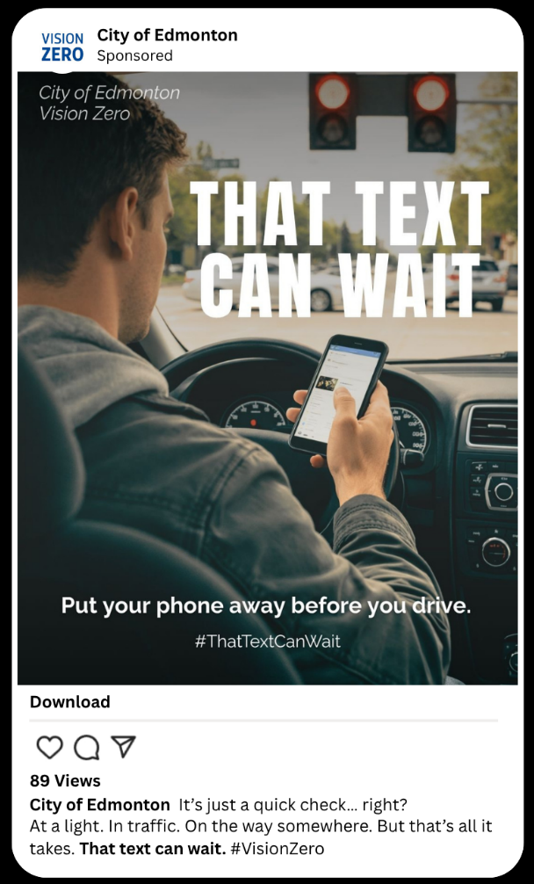 | 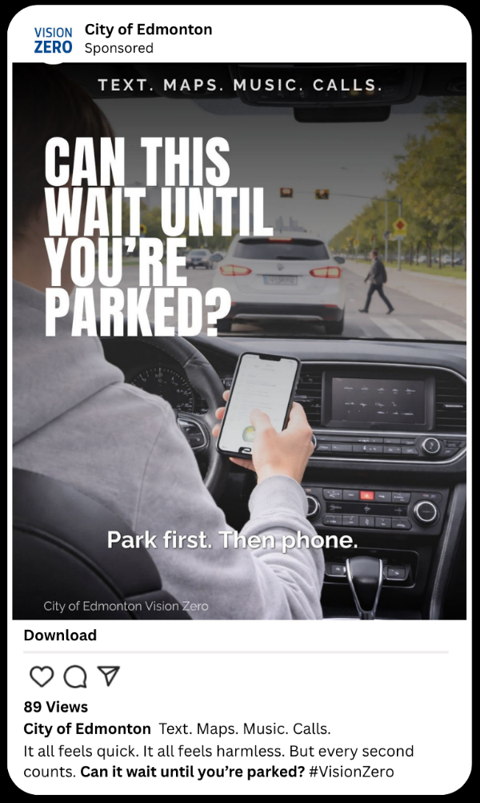 | 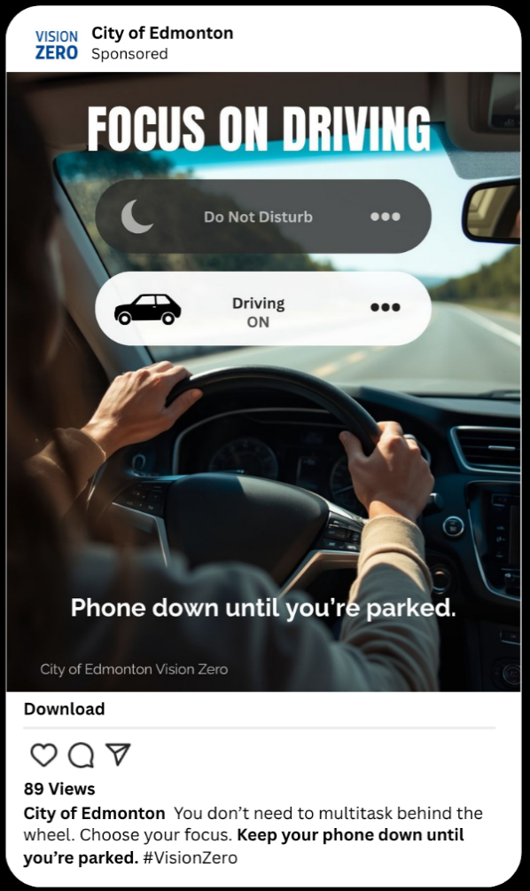
(A) That Text Can Wait | (B) Can This Wait Until You’re Parked? | (C) Focus on Driving

Note. (A) Awareness-based message challenging the urgency of phone use at a red light.
Message strategy: Uses a simple, direct headline to interrupt automatic behaviour and reduce perceived urgency.
AI Image Generation Prompt: A realistic daytime photo from inside a car in Edmonton, Alberta, showing a driver stopped at a red light holding a smartphone and looking down at it. The red traffic light is clearly visible ahead with cross traffic moving. Natural lighting, urban environment, deep depth of field so both the phone and road are in focus. Photorealistic.

(B) Self-reflection message encouraging drivers to reconsider their behaviour in a moment of risk.
Message strategy: Uses a question to prompt self-reflection and increase the likelihood of behaviour change.
AI Image Generation Prompt: A realistic over-the-shoulder view from inside a moving car in Edmonton. The driver is holding a smartphone while driving. The road ahead shows a pedestrian crossing and traffic slowing. Natural daylight, suburban/urban street, deep depth of field with both foreground and background in focus. Clean space for text. Photorealistic.

(C) Behaviour-focused message demonstrating the desired driving behaviour.
Message strategy: Shows the desired behaviour in action, reinforcing control and making the behaviour feel achievable.
AI Image Generation Prompt: A realistic interior car scene from a backseat perspective showing an adult driver with both hands on the steering wheel. No phone visible. Bright natural daylight, open road ahead, clean composition. Photorealistic.

