B2B STRATEGY PAPER: INNOVATION TREND PART 2; CLUBHUB

Chloe MacLeod, Johnathan Jagerhofer, Kayla Lagasse, and Hayley Rathwell.
JR Shaw School of Business, Northern Alberta Institute of Technology
MARK2268 (O01) - Business to Business
Mr. Gilles Prefontaine MBA
June 23, 2023

INTRODUCTION 2
SEGMENTATION AND TARGET MARKETING 4
MACRO-SEGMENTATION CHARACTERISTICS 4
MICRO-SEGMENTATION CHARACTERISTICS 4
REAL-LIFE B2B CUSTOMER EXAMPLE: MICROSOFT CORPORATION 5
• Industry Focus: 6
• Company Size: 6
• Employee Well-Being Priority: 6
• Technologically Savvy: 6
• Correlation to B2B Innovation: 7
B2B CHANNEL STRATEGY 7
DIRECT SALES CHANNEL 8
• Sales Team: 8
• Marketing and Lead Generation: 8
• Customer Support: 9
• Training and Onboarding: 9
POTENTIAL RESOURCES NEEDED FOR SUCCESS IN DIRECT SALES CHANNEL 9
• Sales Representatives: 9
• Marketing Team: 9
• Customer Support Team: 9
• Onboarding Specialists: 9
PARTNERSHIPS WITH EMPLOYEE BENEFITS PROVIDERS CHANNEL 10
• Partner Identification and Negotiation: 10
• Integration and Technical Support: 10
• Co-Marketing Initiatives: 11
• Partnership Manager: 11
• Technical Team: 11
• Marketing Team: 11
B2B SELLING STRATEGY 12
• Targeting Prospective B2B Customers: 13
• Learning from Real-Life Examples: 13
• Salesforce's Approach: LinkedIn Outreach: 13
• Building Confidence with Customer Testimonials - HubSpot Influence: 13
• Inspired by Calm - Industry-Specific Events: 14
• Prioritizing Prospective B2B Customers: 14
• Utilizing Social Selling Tools: 14
• LinkedIn Outreach and Engagement: 14
• Webinars and Thought Leadership: 14
• Personalized Demos and Consultations: 15
• Instilling Confidence with Customer Testimonials: 15
• Emphasizing Customer-Centricity: 15
LINKEDIN SOCIAL MEDIA POST 15
• Discovering Innovative Solutions: 16
• Driving Employee Engagement: 16
• Empowering Professional Growth: 17
• Prioritizing Mental Health: 17
• Remote Team Management: 17
• Measurable Impact and ROI: 17
• Addressing Organizational Challenges: 17
• Collaborative Decision-making: 18
• Time-efficient Information Gathering: 18
• Networking Opportunities: 18
LINKEDIN POST CAPTION: 19
SOCIAL SELLING ENGAGEMENT CONTENT 20
CAPTION: 23
TESTIMONIALS 24
• Builds Trust and Credibility: 24
• Increases Conversion Rates: 24
• Validates Business Claims: 25
• Provides Insight into Customer Experience: 25
• Differentiates from Competitors: 25
• Boosts Online Visibility and SEO: 25
• Encourages Positive Word-of-Mouth: 25
• Enhances Brand Reputation: 26
B2B AWARENESS GENERATION STRATEGY 27
MULTI-CHANNEL COMMUNICATION 28
MEASURING SUCCESS 29
EXPERIENTIAL MARKETING PLAN 29
B2B ADVERTISING CAMPAIGN SAMPLE 30
OBJECTIVE 31
TARGET MARKET 31
MESSAGE 31
VISUAL 31
CALL-TO-ACTION 31
BUDGET 32
MEASUREMENTS 32
ADVERTISING CAMPAIGN SAMPLE (BANNER AD) 32
YOUTUBE PRESENTATION VIDEO 32
REFERENCE LIST 34

INTRODUCTION
ClubHub is an innovative, AI-generated app focused on team building, learning, and mental health support. ClubHub's mission is to satisfy the basic needs of its users, nurturing a sense of community within organizations by providing acknowledgment, understanding, and empathy. This report will explore the various features of ClubHub's B2B marketing strategy, aiming to generate a healthier and more productive workplace on a global scale.
The report will analyze ClubHub's segmentation and target marketing strategy. The company identifies its ideal B2B target market; this is done by examining macro-segmentation and micro-segmentation characteristics. Real-life examples of existing B2B customers will highlight the significance of these segmentation characteristics in pushing promotional activities. The report also outlines a thorough plan for direct and indirect channels, ensuring competent app delivery while aligning with the identified B2B target market. The selling strategy focuses on engaging B2B customers, guiding them through the sales funnel using segmentation characteristics and social selling tools.
ClubHub's B2B awareness generation strategy emphasizes the importance of building market awareness. A compelling communication strategy aligned with the B2B target market will be shown. A comprehensive advertising campaign plan will also be presented to effectively promote ClubHub's B2B innovation in the competitive industry. In conclusion, ClubHub's integrated marketing strategy reflects its commitment to creating healthier, thriving work environments. By understanding its target market, leveraging appropriate channels, and engaging customers effectively, ClubHub is positioned to succeed in the dynamic B2B market.

SEGMENTATION AND TARGET MARKETING

MACRO-SEGMENTATION CHARACTERISTICS
The target market for ClubHub involves businesses and organizations from diverse industries, including technology, healthcare, finance, education, retail, and more. A prominent example of a company that serves various industries is Salesforce, a leading CRM (Customer Relationship Management) supplier (Salesforce, 2023.). Salesforce's CRM platform is widely adopted in sectors such as healthcare, where hospitals and medical facilities use it to manage patient data and appointments. Banks and financial institutions use Salesforce to streamline customer interactions and manage financial data. This diversity in industry focus showcases how ClubHub can be adaptable and relevant to B2B customers with varying requirements.
ClubHub is also for businesses or organizations with over ten employees, available to small and medium-sized enterprises (SMEs) and large corporations. IBM, a multinational technology company, provides a suitable example of catering to businesses of all sizes (IBM, 2023.). IBM offers cloud computing solutions and AI-powered tools that benefit startups and SMEs by developing their operations. IBM's ability to tailor its offerings to businesses of different sizes exemplifies how ClubHub's flexibility supports varying company structures.

MICRO-SEGMENTATION CHARACTERISTICS
The target market for ClubHub consists of businesses and organizations prioritizing their employees' well-being and mental health. Google, recognized for its employee-centric culture, demonstrates this characteristic (Google, 2023.). Google offers many employee wellness programs, mental health resources, and work-life balance initiatives. The company's dedication to promoting employee well-being aligns with ClubHub's focus on mental health support. This makes it a valuable addition to organizations that prioritize the welfare of their workforce.
Additionally, the target market includes technologically savvy organizations actively embracing technological advancements. Microsoft stands at the forefront of adopting AI-driven solutions (Microsoft, 2023.). Microsoft incorporates AI technology into products like Microsoft 365, offering features and enhanced user experiences. Microsoft's openness to adopting AI-driven technologies makes it an ideal target market for ClubHub's AI-generated app, which offers interactive features, personalized recommendations, and a live messenger bot. Aligning with organizations like Microsoft that embrace technological innovations, ClubHub addresses the needs and preferences of its B2B customers.
By incorporating these segmentation characteristics, we can effectively define the target market for ClubHub. The combination of industry focus, company size, employee well-being priority, and technological readiness will guide ClubHub's marketing strategy in successfully addressing the distinct needs and preferences of its B2B customers.

REAL-LIFE B2B CUSTOMER EXAMPLE: MICROSOFT CORPORATION

- Industry Focus: Microsoft Corporation is a technology company that operates in various industries, including technology, healthcare, finance, education, and more. The company offers products and services, such as software, cloud computing, hardware, and enterprise solutions. Microsoft's diverse customers across different sectors make it a suitable B2B customer for ClubHub's target market (Microsoft Corporation, 2023.).

- Company Size: With over 160,000 employees worldwide, Microsoft has a significant workforce. It also works with various business sizes. It is an ideal fit for ClubHub's target market, accommodating businesses with over ten employees (Microsoft Corporation, 2023.).

- Employee Well-Being Priority: Microsoft has a solid commitment to employee well-being and mental health support. The company offers wellness programs, including stress management initiatives, work-life balance resources, and access to mental health counseling. Microsoft's focus on promoting a healthy work environment aligns well with ClubHub's goal of providing mental health support and well-being services (Microsoft Corporation, 2023.).

- Technologically Savvy: Microsoft is a leading technology company in the face of embracing technological advancements. The company implements AI-driven solutions, such as integrating AI into its products and services. Given Microsoft's technological inclination, they would be interested in ClubHub's AI-generated app and its advanced features for team building, learning, and mental health support (Microsoft Corporation, 2023.).

- Correlation to B2B Innovation: ClubHub's B2B innovation perfectly aligns with Microsoft's characteristics. As a technology-driven company focusing on employee well-being, Microsoft could leverage ClubHub's AI platform to offer its workforce additional mental health and wellness support. The customizable features of ClubHub, including multi-language assistance and tailored recommendations, would offer diverse options to Microsoft’s employee base across different countries and cultures (Microsoft Corporation, 2023.). Also, ClubHub's live messenger bot and workplace communication tools could develop internal collaboration and assist communication among Microsoft's teams. Using ClubHub's team-building experiences and learning activities, Microsoft can foster a stronger sense of community and professional growth within its workforce (Microsoft Corporation, 2023.).

In conclusion, Microsoft Corporation is an excellent real-life B2B customer example that fits the target market for ClubHub's B2B innovation. The alignment between Microsoft's industry focus, company size, emphasis on employee well-being, and technological adoption makes them an ideal customer for ClubHub (Microsoft Corporation, 2023.).

B2B CHANNEL STRATEGY

DIRECT SALES CHANNEL
ClubHub employs a direct sales channel strategy to sell its innovative B2B app directly to businesses and organizations, bypassing intermediaries and retaining complete control over the sales process, customer interactions, and user experience. The direct sales channel involves several key activities that are crucial to its success:
- Sales Team: ClubHub maintains an internal sales team of experienced professionals responsible for identifying potential clients, conducting product demonstrations, negotiating contracts, and ultimately closing deals. The sales team plays a critical role in understanding the unique needs of each organization and tailoring the app's features to meet those specific requirements. Example: A similar direct sales approach is adopted by Salesforce, a well-known cloud-based CRM platform. Salesforce's dedicated sales team engages in product demonstrations and negotiations to provide personalized CRM solutions for their clients, enhancing customer interactions and improving overall productivity (Salesforce, 2023).

- Marketing and Lead Generation: To attract potential clients, ClubHub implements targeted marketing strategies, such as digital marketing, content marketing, and participation in industry conferences and events. Lead generation efforts focus on reaching out to HR (Human Resource) departments, organizational leaders, and business owners to highlight the benefits of the app. Example: HubSpot, a leading provider of inbound marketing and sales software, follows a direct sales channel approach with a strong focus on targeted marketing. Their sales team uses digital marketing and content marketing to generate leads and attract potential clients, demonstrating the value of their software in lead generation and customer engagement (HubSpot, 2023).
- Customer Support: Excellent customer support is vital in the B2B space. ClubHub establishes a dedicated customer support team to assist clients with onboarding, technical issues, and any inquiries they may have, ensuring a positive user experience. Typically, it is customary practice among B2B companies to have dedicated customer support teams to provide timely assistance to clients.

- Training and Onboarding: Once a client decides to implement ClubHub, the direct sales channel takes charge of providing comprehensive training and onboarding support. This ensures a seamless integration of the app into the organization's workflow, maximizing its benefits. Onboarding and training support are typical components of B2B direct sales strategies, ensuring a smooth transition for clients.

POTENTIAL RESOURCES NEEDED FOR SUCCESS IN DIRECT SALES CHANNEL
To effectively implement the direct sales channel, ClubHub requires specific resources:
- Sales Representatives: Experienced and knowledgeable sales professionals who can effectively communicate the value of ClubHub to potential clients.
- Marketing Team: Skilled marketers capable of crafting targeted campaigns to generate leads and drive interest in ClubHub.
- Customer Support Team: Trained professionals equipped to handle customer inquiries and provide top-notch support.
- Onboarding Specialists: Experts in guiding clients through the setup and implementation process of ClubHub.

PARTNERSHIPS WITH EMPLOYEE BENEFITS PROVIDERS CHANNEL
The second channel in ClubHub's B2B strategy involves forming partnerships with employee benefits providers, including health insurance companies, EAP (Employee Assistance Program) providers, and corporate wellness platforms. These partnerships aim to extend the app's reach to a wider audience by integrating it into existing benefit packages. Key activities of the partnerships channel include:
- Partner Identification and Negotiation: ClubHub actively identifies potential partners in the employee benefits space and initiates discussions to explore collaboration opportunities. Negotiations are conducted to create mutually beneficial arrangements for both parties. Example: Calm, a popular meditation and mental wellness app, effectively utilizes partnerships with employee benefits providers. By integrating its app into existing benefit packages offered by health insurance companies and corporate wellness platforms, Calm gains access to a broader user base and becomes part of a holistic employee wellness program (Calm, 2023).

- Integration and Technical Support: Once a partnership is established, ClubHub's technical team collaborates closely with the benefits provider's IT team to ensure the seamless integration of the app into their platforms. Example: Headspace, another meditation and mindfulness app, follows a similar partnerships channel strategy. With their "Headspace for Work" program, Headspace integrates its mindfulness content into existing corporate wellness programs and employee assistance programs, making it easily accessible to employees (Headspace, 2023).
- Co-Marketing Initiatives: Collaborative marketing efforts with benefits providers help promote ClubHub to their existing customer base, highlighting the app's benefits as part of their comprehensive employee benefits package. Co-marketing initiatives are common among B2B companies partnering with employee benefits providers to maximize the app's visibility.

POTENTIAL RESOURCES NEEDED FOR SUCCESS IN PARTNERSHIPS CHANNEL
To make the most of the partnerships channel, ClubHub requires specific resources:
- Partnership Manager: A dedicated professional responsible for identifying potential partners and managing the relationship with employee benefits providers.
- Technical Team: Skilled IT professionals capable of ensuring smooth integration with various benefits platforms.
- Marketing Team: To develop co-marketing strategies and promotional materials for partnership initiatives.

The integration of real-life examples, such as Salesforce and HubSpot for the direct sales channel, and Calm and Headspace for the partnerships channel, provides practical insights into how companies effectively implement B2B channel strategies. By leveraging both direct sales and partnerships with employee benefits providers, ClubHub can effectively deliver its innovative B2B app to its target market, catering to the unique needs of organizations and enhancing team building, learning, and mental health support services. The seamless flow of information and relevant examples ensures a comprehensive understanding of the topics discussed in the B2B channel strategy for ClubHub.

B2B SELLING STRATEGY
ClubHub's B2B Selling Strategy engages the B2B Customer effectively and guides them through the sales funnel.
- Targeting Prospective B2B Customers: The identification of leads is based on the B2B Segmentation characteristics, which target businesses prioritizing employee well-being in diverse industries such as technology, healthcare, finance, and education.
- Learning from Real-Life Examples: By adopting successful B2B Selling Strategies from real-life examples like Salesforce, HubSpot, and Calm, ClubHub aims to attract potential customers and create connections with central decision makers.
- Salesforce's Approach: LinkedIn Outreach: Pulling from Salesforce's approach, ClubHub plans to utilize LinkedIn outreach to connect with individuals within target organizations. Through LinkedIn engagement, ClubHub's sales representatives will share valuable content and insights about the AI-generated app for team building, learning, and mental health support (Salesforce, 2023.).
- Building Confidence with Customer Testimonials - HubSpot Influence: ClubHub aims to build trust and credibility with potential customers, nurturing leads and guiding them through the sales funnel. Like HubSpot, ClubHub recognizes the influence of customer testimonials in building confidence among potential buyers (HubSpot, 2023.). By presenting real-life examples of how the app positively impacts employee well-being and team-building experiences, ClubHub seeks to instill confidence and demonstrate the value of using the app.
- Inspired by Calm - Industry-Specific Events: Additionally, inspired by Calm's success, ClubHub plans to participate in industry-specific events and conferences to reach employee benefits providers and decision-makers in organizations that prioritize their employees' mental health (Calm, 2023.). By demonstrating the value of ClubHub as an essential component of employee well-being programs, it aims to expand its reach and explore opportunities in existing benefit packages.
- Prioritizing Prospective B2B Customers: In prioritizing prospective B2B Customers, ClubHub's strategy considers organizations that prioritize employee well-being, embrace technological advancements, and hold significant industry influence. By prioritizing these customers, ClubHub aims to strengthen its market presence and attract more clients, like Salesforce, HubSpot, and Calm focus on targeting specific customers to maximize their impact.
- Utilizing Social Selling Tools: To engage the B2B Customer effectively and enable the evaluation and purchase process, ClubHub plans to utilize various social selling tools.
- LinkedIn Outreach and Engagement: Inspired by Salesforce's LinkedIn outreach, ClubHub will connect with key individuals in target organizations, sharing relevant content and testimonials to build trust and engagement (Salesforce, 2023).
- Webinars and Thought Leadership: Additionally, webinars and thought leadership content will position ClubHub as an industry expert, offering valuable insights and solutions for team building, learning, and mental health support.
- Personalized Demos and Consultations: Personalized demos and consultations will address specific features and demonstrate the app's value to potential buyers.
- Instilling Confidence with Customer Testimonials: By integrating customer testimonials into the strategy, ClubHub aims to further instill confidence in potential buyers, just as HubSpot effectively utilizes such examples (HubSpot, 2023.). Consistent follow-up and nurturing efforts will maintain relationships with leads and guide them through the sales funnel.
- Emphasizing Customer-Centricity: ClubHub's B2B Selling Strategy emphasizes customer-centricity and leverages real-life B2B customer opinions to ensure a complete and practical approach.
Drawing from the success of companies like Salesforce, HubSpot, and Calm, ClubHub hopes to engage the B2B Customer effectively, from identifying leads to guiding them through the evaluation process and ultimately driving them towards purchasing ClubHub for team building, learning, and mental health support.

LINKEDIN SOCIAL MEDIA POST
LINKEDIN
Done properly, webinars are a game changer. In a recent survey:
- 64% of content marketers said virtual events, webinars, and online courses made up a key part of their ongoing content strategy.
- 58% of these respondents also said their webinars produced the best results of all the content they produced all year.
- 66% of the respondents who indicated the success of their webinars were the respondents LinkedIn had marked among “top performers.” (Rynne, 2022).
WEBINARS
A webinar showcasing the app ClubHub, designed for team building, learning, and mental health support, would be crucial for decision-makers of a business to attend for several compelling reasons:
- Discovering Innovative Solutions: Decision-makers are constantly seeking innovative solutions to enhance their team's dynamics and productivity. Attending the webinar will provide them with a firsthand understanding of how ClubHub offers unique and effective approaches to team building, learning, and mental health support.
- Driving Employee Engagement: Employee engagement is a top priority for any business leader. ClubHub offers interactive team-building activities that can strengthen relationships, foster a positive work environment, and ultimately boost employee engagement levels. Decision-makers can learn how this app can contribute to a more motivated and committed workforce.
- Empowering Professional Growth: For businesses to thrive, continuous learning and development are essential. The webinar will demonstrate how ClubHub facilitates personalized learning paths and provides access to a diverse range of educational resources, empowering team members to grow their skills and knowledge.
- Prioritizing Mental Health: Decision-makers are increasingly recognizing the importance of employee well-being and mental health support. ClubHub offers tools and activities to nurture mental health within the workplace, promoting resilience and reducing stress levels, leading to a healthier and more productive workforce.
- Remote Team Management: In today's globalized and remote work environment, managing and fostering team collaboration can be challenging. Decision-makers will learn how ClubHub adapts to remote teams, ensuring that team building, and support activities are accessible and impactful, regardless of geographical locations.

- Measurable Impact and ROI: As decision-makers, they seek investments that deliver a measurable return on their investment. The webinar will showcase success stories and case studies of businesses that have implemented ClubHub and experienced improved team performance, employee satisfaction, and overall productivity.

- Addressing Organizational Challenges: Every business faces unique challenges. The webinar will allow decision-makers to assess how ClubHub can address specific pain points within their organization, whether it's communication issues, employee disengagement, or skill gaps.

- Collaborative Decision-making: Attending the webinar as decision-makers enables them to collaborate with their team and HR professionals to collectively assess the suitability of ClubHub for their organization. Hearing insights and feedback from team members can facilitate better decision-making.

- Time-efficient Information Gathering: Webinars provide a concentrated and efficient way to gather comprehensive information about ClubHub without requiring extensive research or resource allocation. (Rynne, 2022). Decision-makers can obtain valuable insights within a short timeframe.
- Networking Opportunities: Webinars often offer networking opportunities with other decision-makers and industry experts attending the event. This can lead to valuable connections, knowledge sharing, and potential partnerships (Sacko, 2022).

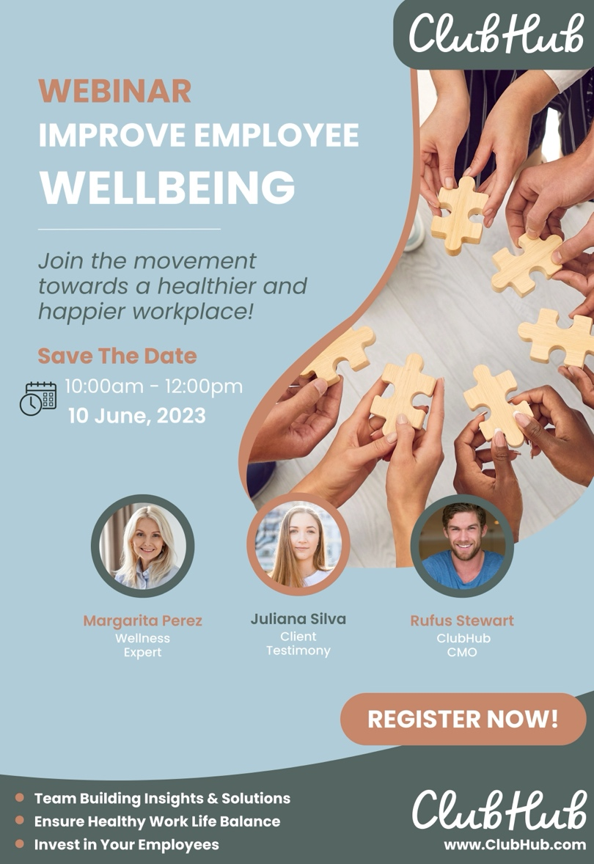

LINKEDIN POST CAPTION:
🌟 Free Live Webinar Alert! 🌟
Are you looking to foster a stronger sense of camaraderie within your team? Want to enhance your learning opportunities and prioritize mental well-being in the workplace? Look no further – ClubHub has got you covered!
📅 Date: June 10th, 2023
⏰ Time: 10:00 am-12:00 pm
📍 Location: Online – Register Now!
In this webinar, you'll learn how ClubHub has revolutionized the way teams connect, grow, and support each other remotely or in-person. Say goodbye to mundane icebreakers and hello to engaging team-building activities tailored to your group's interests and goals! 🎯
Whether you're a team leader, HR professional, or simply passionate about personal development, this session will showcase how ClubHub can create a positive impact on your organization's culture and productivity.
Key Topics Covered 🔑:
• Innovative Team Building Strategies
• Seamless Learning & Skill Development
• Nurturing Mental Health in the Workplace
Join us to explore the app that has been transforming team dynamics and fostering a positive work environment for companies of all sizes! Don't miss this chance to revolutionize the way you approach team building and mental health support. Let's build stronger, healthier, and happier teams together! 💪
Reserve your spot now by clicking the link below! 👇🏼
www.SignUpHere.com
#ClubHub #TeamBuilding #RemoteTeamManagement #MentalHealthMatters #LearningAndDevelopment #ProfessionalGrowth #WorkplaceWellness #EmployeeEngagement #WebinarAlert #RegisterNow

SOCIAL SELLING ENGAGEMENT CONTENT
Introducing our Social Selling Engagement Content video ad - a captivating and concise Facebook sponsored advertisement designed to raise awareness among businesses and decision-makers about our upcoming webinar. With ClubHub's targeted approach, we aim to reach the right audience, analyze valuable analytics, and gather crucial data to ensure an effective and successful campaign. Join us and take your social selling strategies to the next level!
- https://www.canva.com/design/DAFpdqbdbSY/hKtjN2DUe29KI1irBzG9yw/watch?utm_content=DAFpdqbdbSY&utm_campaign=designshare&utm_medium=link&utm_source=publishsharelink
This short video ad will be a paid advertisement on Facebook, targeted toward businesses and decision makers to gain awareness of the webinar being held. This allows ClubHub to track analytics and data.
- Audience Targeting: Facebook allows advertisers to target their ads to specific audiences based on various factors, such as demographics, interests, behaviors, and location. This level of granular targeting ensures that the ads are shown to people who are more likely to be interested in the product or service being promoted, increasing the chances of engagement and conversion (Georgiadis, 2022).

- Large User Base: Facebook has an enormous user base, with billions of active users worldwide. This vast reach means that ClubHub can potentially reach a significant portion of their target audience, maximizing the exposure of their ads (Bernazzani, 2022).
- Data and Insights: Facebook collects a vast amount of data about its users, including their interests, online behavior, and social connections. This allows ClubHub to tap into this data to better understand the audience and create highly relevant and personalized ads, which can lead to higher engagement and conversion rates (Georgiadis, 2022).

- Ad Formats and Creatives: Facebook offers a variety of ad formats, such as image ads, video ads, carousel ads, and more. ClubHub can choose the format that best suits their campaign objectives and create visually appealing and engaging creatives to capture users' attention.

- Retargeting: Facebook enables retargeting, which means ClubHub can show ads to users who have previously interacted with their website or engaged with their content. This approach can be highly effective in re-engaging potential customers and nudging them towards making a purchase (Sacko, 2022).

- Insights and Analytics: Facebook provides detailed insights and analytics on ad performance, allowing ClubHub to track key metrics, analyze the effectiveness of their campaigns, and make data-driven decisions to optimize future ads.

- Overall, the combination of precise audience targeting, a vast user base, data-driven insights, and flexible ad formats makes paid targeted ads on Facebook an effective marketing tool for businesses seeking to reach and engage their target audience in a cost-efficient manner.

INSTAGRAM
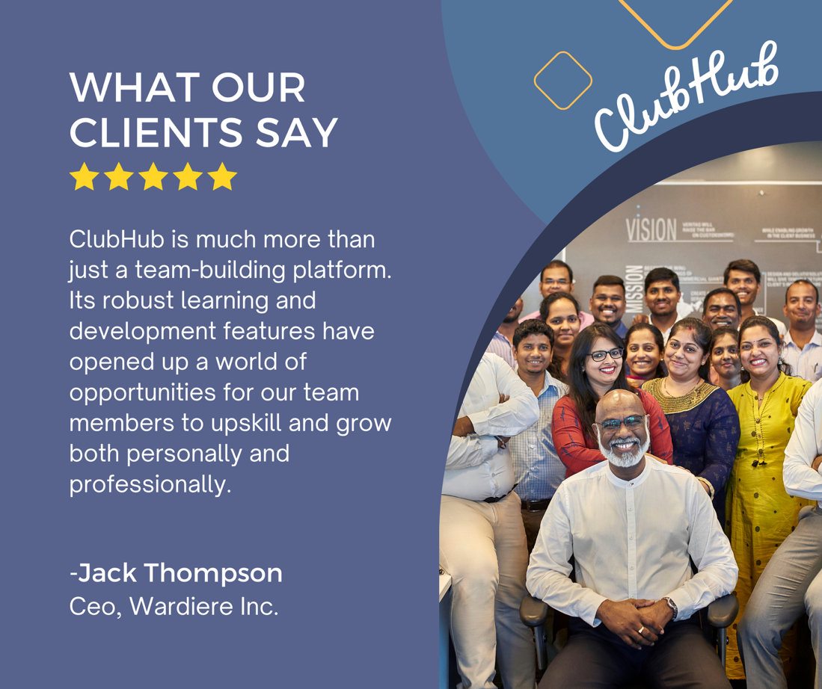

CAPTION:
At ClubHub, we are grateful for our happy Clients! ⭐
“ClubHub is much more than just a team-building platform. Its robust learning and development features have opened up a world of opportunities for our team members to upskill and grow both personally and professionally. The diverse range of learning resources and courses has empowered them to take charge of their development journeys, making them more valuable assets to our organization.” - Jack Thompson, CEO Wardiere Inc.
Click our link in our bio to learn more!
#ClubHub #TeamBuilding #RemoteTeamManagement #MentalHealthMatters #LearningAndDevelopment #ProfessionalGrowth #WorkplaceWellness #EmployeeEngagement
OR
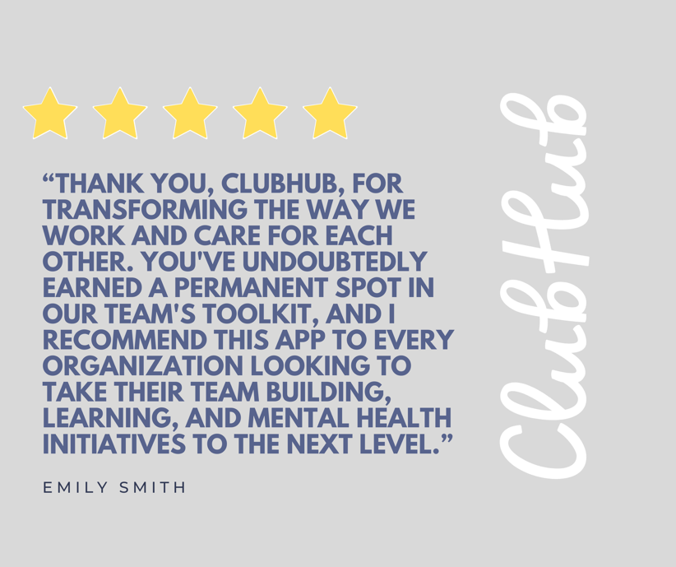

TESTIMONIALS
These two client testimonials options are incredibly beneficial to a business's growth for several reasons:
- Builds Trust and Credibility: Testimonials provide social proof that real customers have had positive experiences with the business's products or services. Potential customers are more likely to trust the opinions and experiences of other customers rather than just relying on the company's marketing messages (Sacko, 2022).
- Increases Conversion Rates: Positive testimonials can have a significant impact on the conversion rates of a business. When potential customers see positive feedback from others, it can persuade them to take the desired action, such as making a purchase or signing up for a service (Georgiadis, 2022).

- Validates Business Claims: Testimonials can reinforce the claims and promises made by the business in its marketing efforts. It shows that the business is delivering on its value proposition and meeting the expectations of its customers (Rajan, 2017).

- Provides Insight into Customer Experience: Testimonials often include specific details about the customer's experience with the product or service. This feedback can be valuable for the business to understand what aspects of their offerings are resonating with customers and what areas might need improvement (Rajan, 2017).

- Differentiates from Competitors: In a competitive market, positive testimonials can be a differentiating factor that sets a business apart from its competitors. When potential customers see that others have had a great experience, they may choose one business over another.

- Boosts Online Visibility and SEO: Testimonials, especially when posted on the company's website or social media pages, can improve search engine optimization (SEO). Fresh and relevant content, such as testimonials, can increase the website's visibility in search engine results (Rajan, 2017).

- Encourages Positive Word-of-Mouth: Satisfied customers who provide testimonials are more likely to become brand advocates and share their positive experiences with friends, family, and colleagues. This word-of-mouth marketing can bring in new customers and expand ClubHub’s reach (Rajan, 2017).

- Enhances Brand Reputation: A collection of positive testimonials contributes to building a strong brand reputation. A well-regarded brand is more likely to attract new customers and retain existing ones.

Client testimonials are a powerful tool for ClubHub to showcase their credibility, gain the trust of potential customers, and foster growth. They provide valuable insights, build brand reputation, and can have a significant impact on the overall success of ClubHub’s business.

B2B AWARENESS GENERATION STRATEGY

ClubHub has opted for an Experiential Marketing Plan as the direction of choice for its Awareness Generation Strategy. This plan is necessary for connecting with their target market, which comprises businesses and organizations with at least ten employees who prioritize team building, learning, and mental health within their culture. To ensure effective communication with the target audience, ClubHub will employ multiple communication channels, including social media marketing, email marketing, content marketing, and digital advertising. The messaging for each channel will be crafted to be on-brand and consistent, highlighting the app's value proposition for team building, learning, and mental health support. Additionally, the visual identity and brand personality characteristics will focus on creating a modern and user-friendly design that aligns with the company's goal of fostering community and well-being within organizations.

MULTI-CHANNEL COMMUNICATION
For social media marketing, ClubHub will use platforms like LinkedIn, Twitter, and Facebook to promote their experiential marketing events, share industry-specific content, and engage with potential customers. The messaging will focus on establishing ClubHub as a valuable resource for organizations seeking to improve team building, learning, and mental health support. Furthermore, email marketing will be employed to promote the experiential marketing events and follow up with potential customers after the events. The messaging will be personalized and tailored to the recipient's interests, highlighting the specific features and benefits of ClubHub that are most relevant to their needs.
Finally, digital advertising will build brand awareness for ClubHub through banner ads on LinkedIn, Google Ads, Facebook Ads, and Twitter Ads. The messaging will focus on the app's value proposition for team building, learning, and mental health support, and will be designed to be visually appealing and attention-grabbing.

MEASURING SUCCESS
By utilizing various communication channels and consistent messaging, ClubHub can reach a wider audience and reinforce its message across different touchpoints, increasing the likelihood of generating leads and building awareness for the app. Success will be measured using specific quantitative and qualitative measures, such as the number of attendees at events, the number of leads generated, increased brand awareness, and feedback from potential customers on the app's features and benefits.

EXPERIENTIAL MARKETING PLAN
ClubHub's Experiential Marketing Plan is a six-month timeline that allows for thorough planning, execution, and follow-up. The first month will be dedicated to planning and organizing experiential marketing events, including identifying the target audience, selecting event locations, and coordinating event logistics. The team will also develop marketing materials and outreach strategies to promote the events during this stage.
The following two to three months will be dedicated to hosting experiential marketing events that showcase ClubHub's features and benefits through interactive and engaging activities, allowing attendees to experience the app's capabilities firsthand. The events will also enable ClubHub to establish personal relationships with potential customers, building trust and credibility.
In the final month of the timeline, ClubHub will gather feedback from attendees and analyze the results of the experiential marketing events. This stage is critical for evaluating the plan's success and identifying areas for improvement. The team will use the feedback gathered to refine the messaging and marketing strategies for future campaigns.

ESTIMATED BUDGET
The estimated budget for ClubHub's Experiential Marketing Plan is around $100,000. This includes costs for event planning and coordination, event execution, marketing and promotion, speaker and content development, visual identity and brand personality characteristics, and feedback and analysis. Additionally, an advertising plan will be implemented, which includes banner ads on LinkedIn, Google Ads, Facebook Ads, and Twitter Ads, with an estimated cost of $5,000 each.

By dedicating sufficient time and resources to planning, execution, and follow-up, ClubHub is well-positioned to achieve its overall objectives of generating leads and increasing brand awareness.

B2B ADVERTISING CAMPAIGN SAMPLE

OBJECTIVE
To create awareness of ClubHub, a mental health and wellness app that fosters community and well-being within organizations, among businesses and organizations with at least ten employees who prioritize team building, learning, and mental health within their culture.

TARGET MARKET
Businesses and organizations with at least ten employees prioritizing team building, learning, and mental health within their culture.

MESSAGE
Join the movement towards a healthier and happier workplace.

VISUAL
The banner ad will have a simple and clean design that aligns with ClubHub's brand personality characteristics of inclusivity, innovation, and empathy. The visual will include bright colours and clean lines to create a modern, user-friendly design. The ad will feature an image of a diverse group of people smiling and interacting with each other, emphasizing the community aspect of the app.

CALL-TO-ACTION
The banner ad will include a clear and compelling call to action, such as “Sign up for ClubHub today and transform your workplace culture!” The call-to-action will be prominently displayed in bold letters, with a button that leads to a landing page where potential customers can learn more about the app and sign up for a free trial.

BUDGET
The budget for the online banner ad campaign will be $5,000.

MEASUREMENTS
The success of the online banner ad campaign will be measured through metrics such as the number of clicks on the ad, the number of sign-ups for the free trial, and the increase in brand awareness among the target market.

ADVERTISING CAMPAIGN SAMPLE (BANNER AD)


YOUTUBE PRESENTATION VIDEO
ClubHub


CONCLUSION
In conclusion, ClubHub's B2B segmentation and target marketing strategy, combined with real-life examples like Microsoft Corporation demonstrate the company's ability to effectively cater to businesses and organizations with diverse needs and preferences. By focusing on industry diversity, company size, employee well-being, and technological readiness, ClubHub can successfully address the distinct requirements of its B2B customers. The two channels of the B2B channel strategy, direct sales, and partnerships with employee benefits providers, offer valuable insights into how ClubHub can reach its target market and expand its market presence.
Inspired by successful companies, ClubHub's B2B selling strategy prioritizes customer-centricity and utilizes social selling tools to engage and guide potential customers through the sales funnel effectively. By leveraging these strategies, ClubHub is poised to provide innovative solutions for team building, learning, and mental health support to businesses and organizations worldwide.
ClubHub's upcoming webinar, focusing on team building, learning, and mental health support, presents a compelling opportunity for decision-makers in businesses. The webinar promises to offer innovative solutions for enhancing team dynamics, driving employee engagement, and empowering professional growth. Moreover, it addresses the increasingly important aspect of mental health support within the workplace, catering to remote team management challenges as well.
ClubHub's Experiential Marketing Plan, with its well-planned timeline and dedicated efforts towards hosting engaging events, promises to be an effective approach for connecting with their target market and generating leads. By allocating the estimated budget to various marketing efforts, ClubHub is well-prepared to achieve their objectives of raising awareness and fostering a positive impact on workplace cultures. Through a compelling message, captivating visuals, and clear calls-to-action, ClubHub aims to attract businesses and organizations seeking to create healthier and happier workplaces.

REFERENCE LIST

Bernazzani, S. (2022, July 14). 15 of the Best Facebook Ad Examples That Actually Work (And Why). HubSpot Blog. Retrieved from
https://blog.hubspot.com/blog/tabid/6307/bid/33319/10-examples-of-facebook-ads-that-actually-work-and-why.aspx

Burt, T. (2021, October 18). Data Suggests a Huge Year Is Ahead for B2B Content Marketing. LinkedIn Business: Marketing Blog. Retrieved from https://www.linkedin.com/business/marketing/blog/trends-tips/data-suggests-a-huge-year-is-ahead-for-b2b-content-marketing?trk=lms-blog-liproduct&src=bl-po
Calm. (2023). About Calm. Retrieved from https://blog.calm.com/about

Georgiadis, C. (2022, July 12). Why Webinars Should Be a Key Part of Your Business's Online Strategy. Entrepreneur. Retrieved from https://www.entrepreneur.com/growing-a-business/webinars-should-be-a-key-part-of-your-businesss-online/429680

Google. (2023). Google Careers - Life at Google. Retrieved from https://careers.google.com/locations/

Grabowski, S. (2019, April 11). 7 Practical Steps to Host Webinars That Drive Sales. Entrepreneur. Retrieved from https://www.entrepreneur.com/growing-a-business/7-practical-steps-to-host-webinars-that-drive-sales/331639

Headspace. (2023). About Us. Retrieved from https://www.headspace.com/about-us

HubSpot. (2023). Our Story. HubSpot. Retrieved from https://www.hubspot.com/about/company

IBM. (2023). IBM Cloud. Retrieved from https://www.ibm.com/cloud

Microsoft. (2023) Microsoft 365. Retrieved from https://www.microsoft.com/en-us/microsoft-365

Microsoft Corporation. (2023). Microsoft: Official Home Page. Retrieved from https://www.microsoft.com/

Rajan, V. (2017, June 15). Top Seven Overlooked Benefits Of Testimonials. Forbes. Retrieved from https://www.forbes.com/sites/forbescoachescouncil/2017/06/15/top-seven-overlooked-benefits-of-testimonials/?sh=65fb79cc1ccd

Rynne, A. (2022, October 5). How to Expertly Promote Your Webinar on LinkedIn. LinkedIn Business: Marketing Blog. Retrieved from https://www.linkedin.com/business/marketing/blog/content-marketing/how-to-expertly-promote-your-webinar-on-linkedin

Sacko, M. (2022, April 27). What Is A Webinar? – Why Are Webinars So Effective? LinkedIn. Retrieved from https://www.linkedin.com/pulse/what-webinar-why-webinars-so-effective-mamadou-sacko/

Salesforce. (2023). About Us - Salesforce. Salesforce. Retrieved from https://www.salesforce.com/company/

Salesforce. (2023). Salesforce CRM. Retrieved from https://www.salesforce.com/

